BC Spa Pedicure Collection
$60.00
Instant Foot Scrub | $22
Foot Spray | $22
Cooling Foot Salve | $22

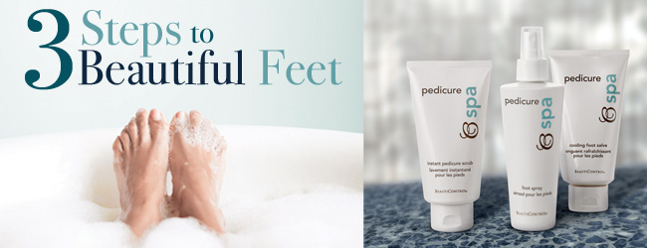

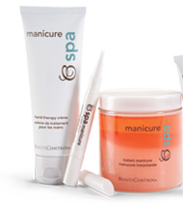
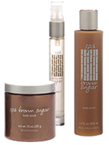
BC Spa Brown Sugar Set
$78.00
Body Scrub | $26.00
Cologne | $32.75
Body Lotion | $26.00

BC Spa Manicure Set
$55.00
Hand Creme | $15
Cuticle Oil Pen | $16
Instant Manicure | $30

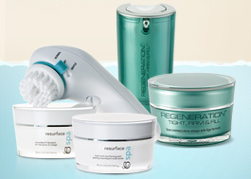
BC Spa Instant Face Lift Set
$220.00
Microderm Abrasion | $60.00
Facial Buffer | $16.50
Resurfacing Peel | $55.00
TFF Face Creme | $50.00
TFF Eye Firming Serum | $46.50

Book a Spa
& receive 40% off
TFF
(up to $20 savings)

BC Spa Daily Anti-Aging Facial Set
$190.50
Purifying Cleanser  Lotion / Gel | $26.50
Exfoliating Polish | $22.00
Regenerating Tonic  with PHAs/ with AHAs | $26.50
Defend & Restore Day Crème (SPF 20)  Crème / Lotion | $35.00
Restructuring Eye Crème | $38.50
Defend & Restore Night Crème | $42.00

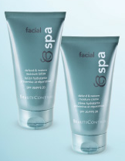
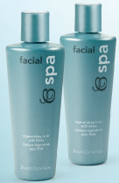

Book a Spa
& receive 40% off
($76 savings)

